# **Software Engineering Assignment**

**MODULE: 2 SE – HTML and CSS**

**Define the following terms:**

1. **Website: A collection of webpages found under a single domain.**
2. **Webpage: A document available on world wide web.**
3. **Web browser: A browser is a search engine.**
4. **Web server: A server that helps to run a particular website.**
5. **HTML: It stands for Hyper Text Markup Language. However, it helps in linking the web pages and also helps to give various effects over the web pages.**
6. **CSS: It stands for Cascading Style Sheet. It helps to apply the effects on the websites.**

**Create a webpage to show “This is my first HTML page”**

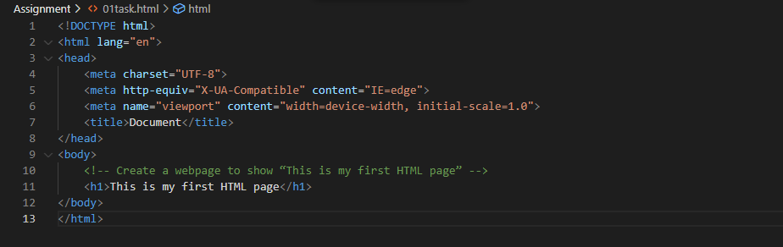

**OUTPUT:**

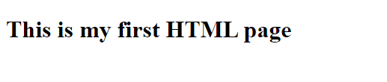

**Display top 10 IT companies list in html webpage**

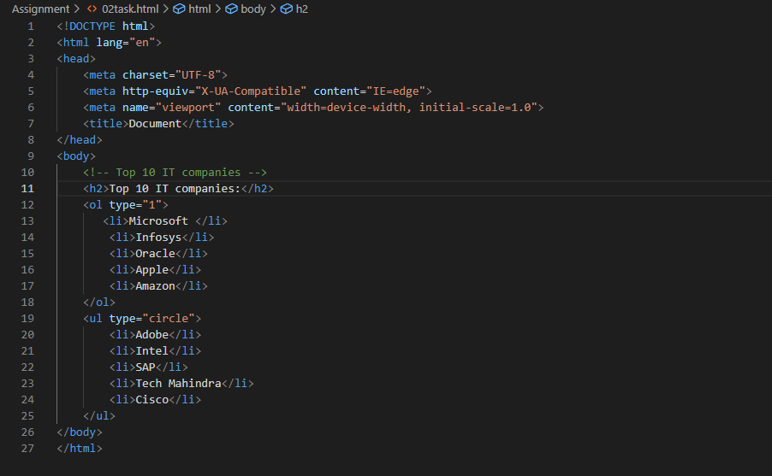

**OUTPUT:**

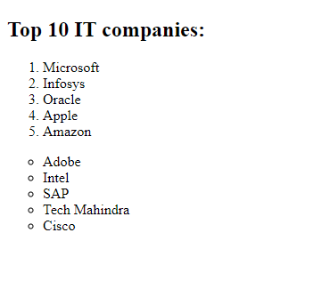

**Create a dropdown list**

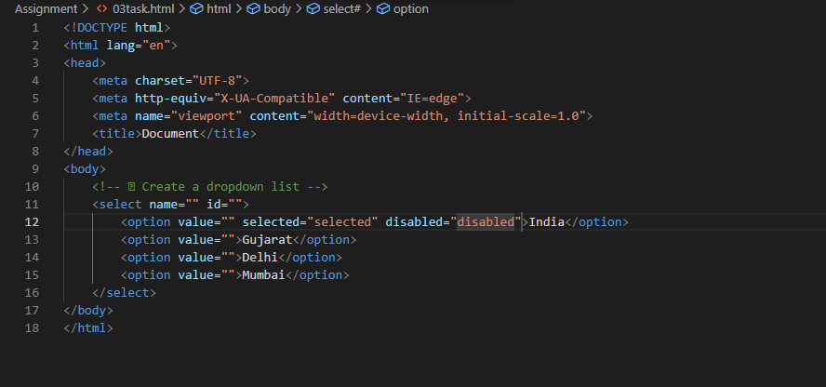

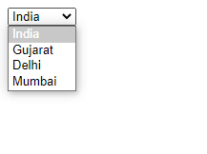**OUTPUT:**

**Create a Table Of college Management system using row span & col span.**

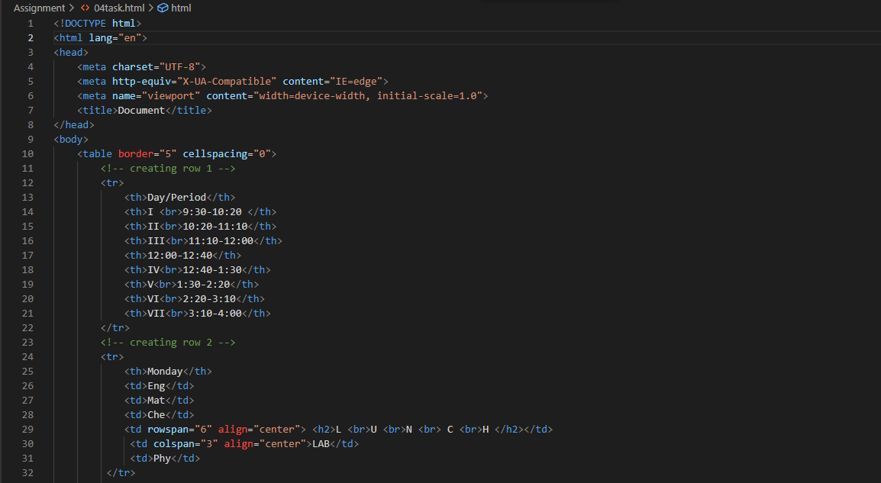

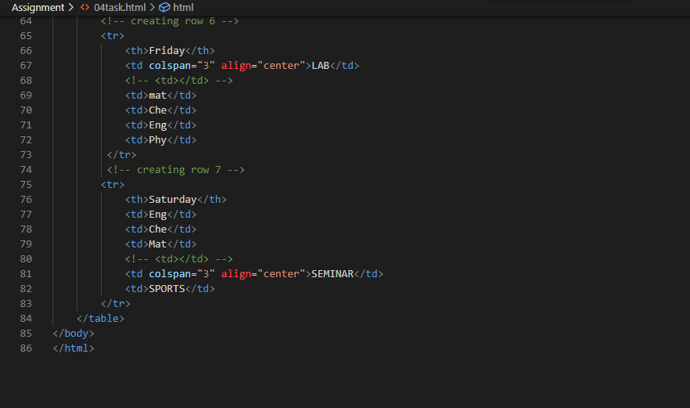

**OUTPUT:**

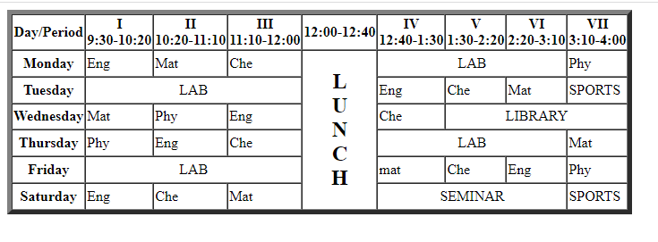

**Create below table using HTML table tags**

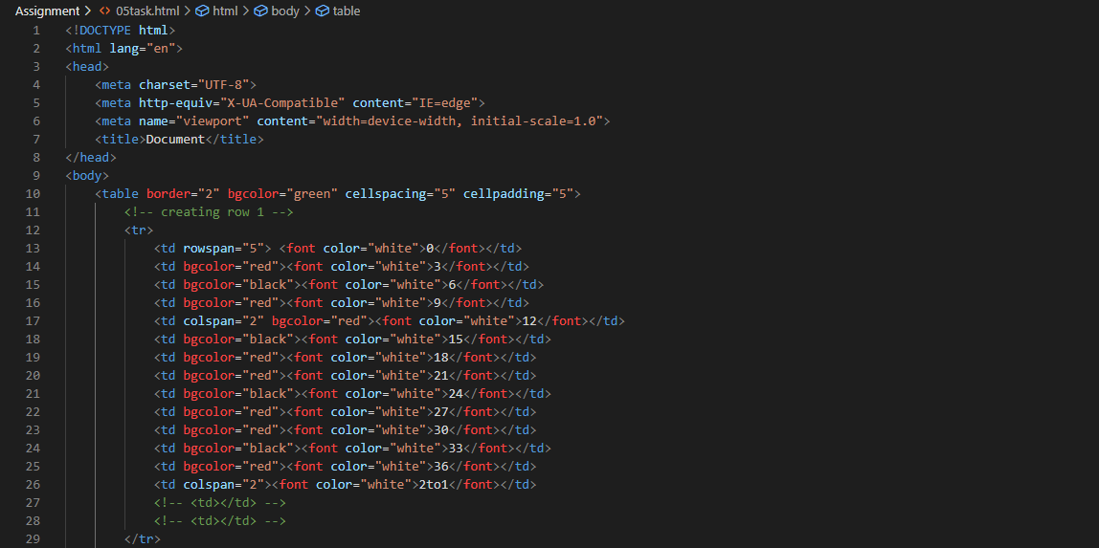

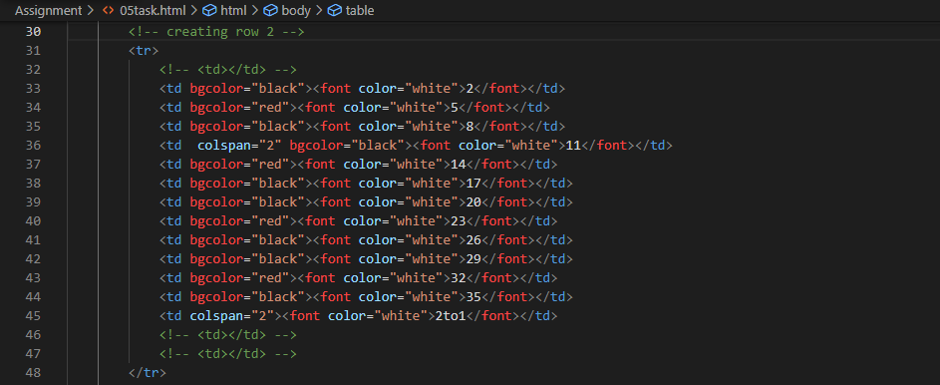

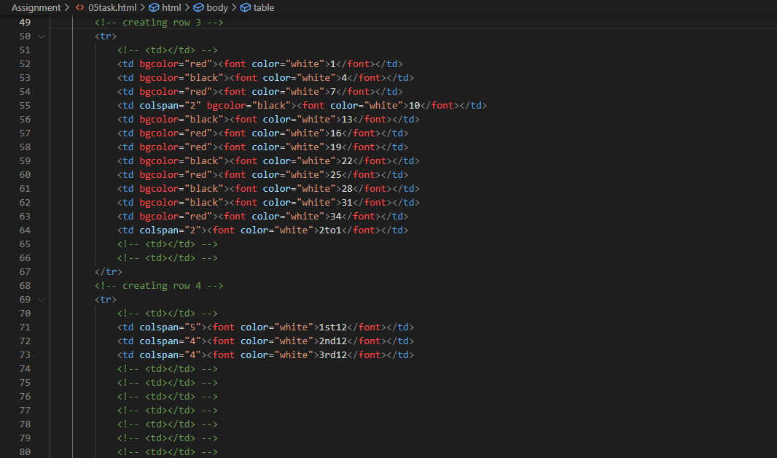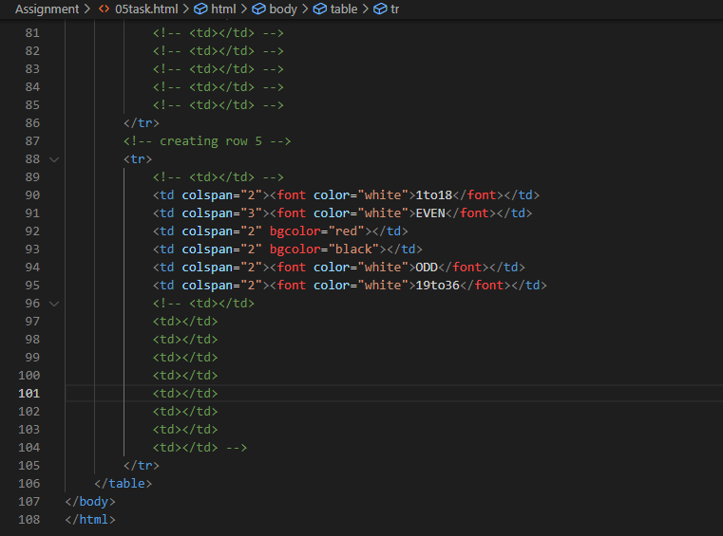

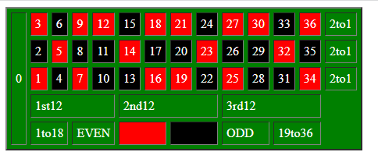**OUTPUT:**

**Create Registration form using HTML, CSS**

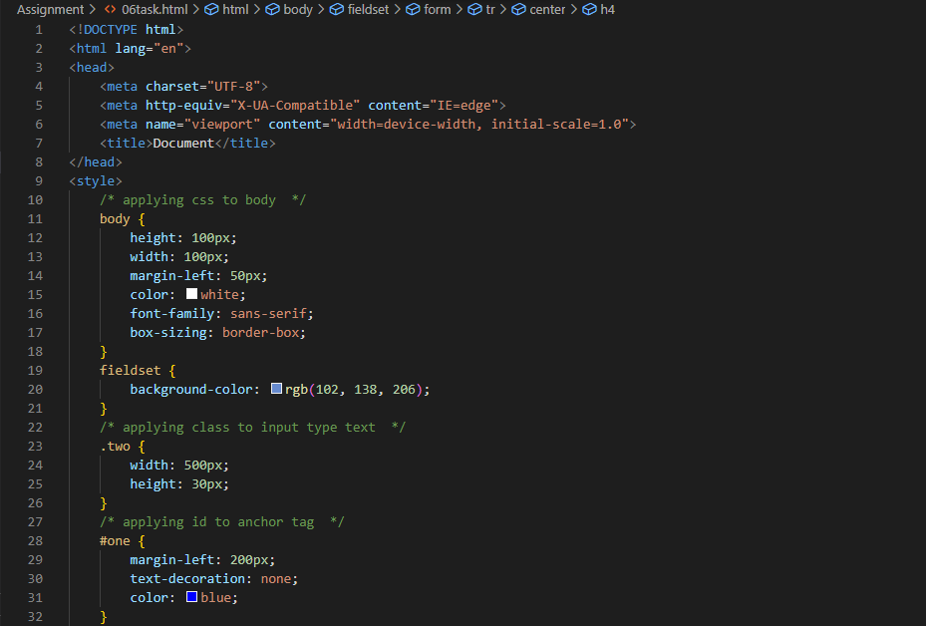

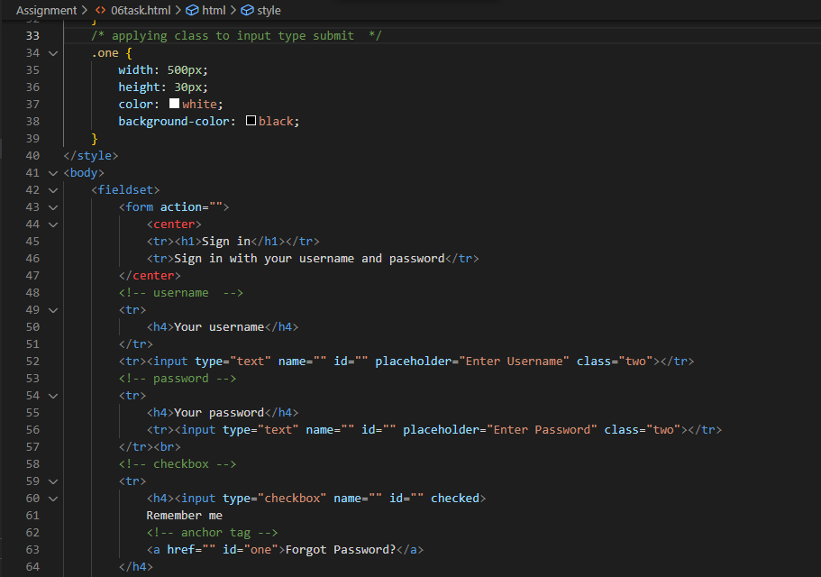

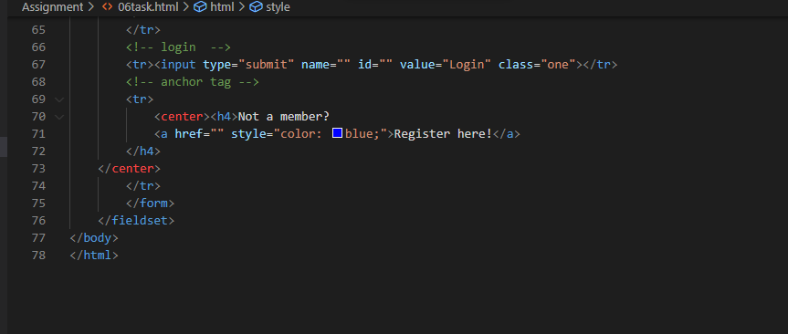

**Output:**

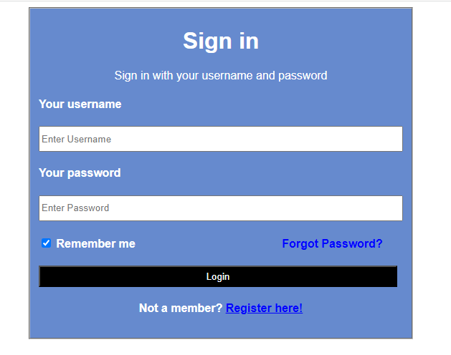

**In how many ways can a CSS be integrated as a web page?**

CSS can be integrated in 3 ways:

1. Inline
2. Internal
3. External

**Create simple three pages using External CSS, Internal CSS, and Inline CSS.**

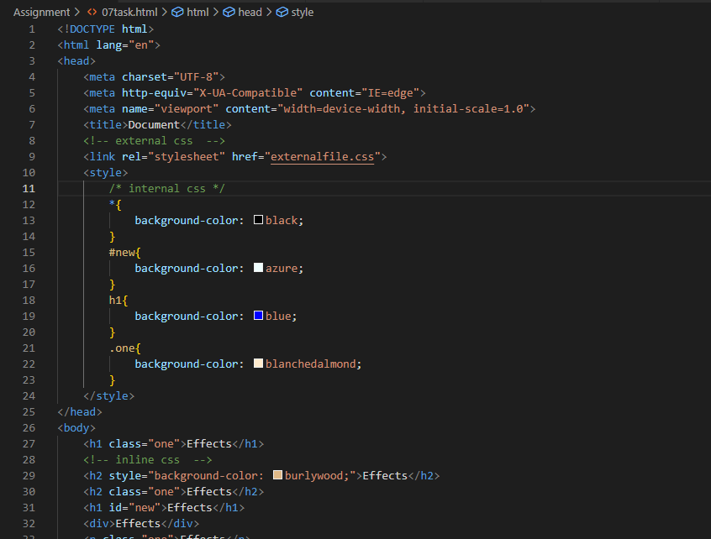

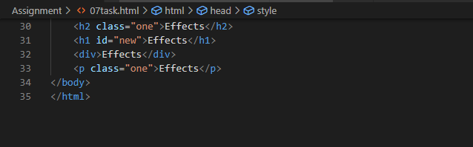

**OUTPUT:**

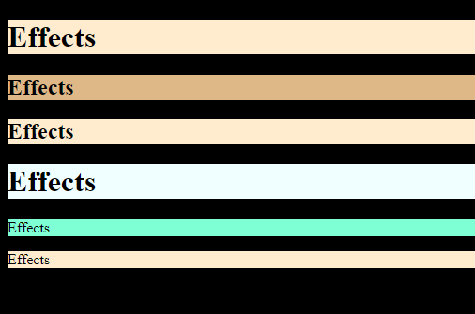

**Create below page using HTML CSS**

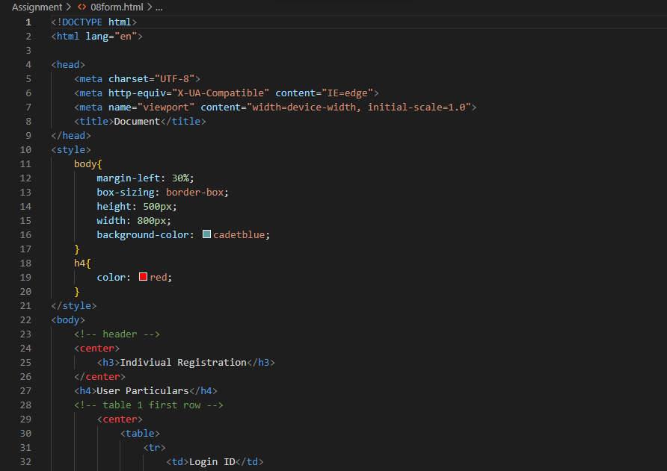

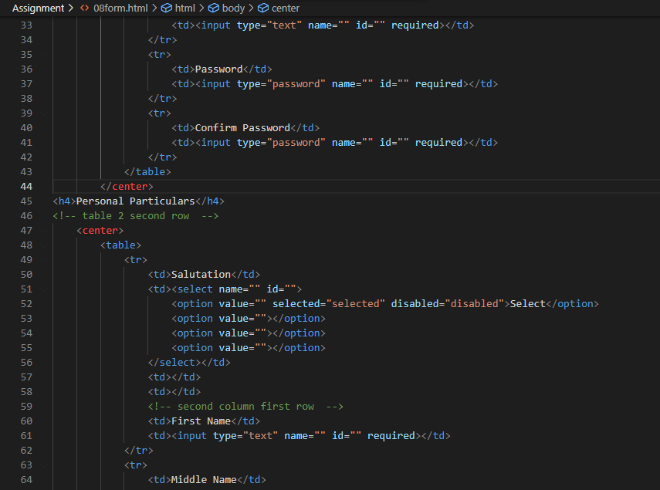

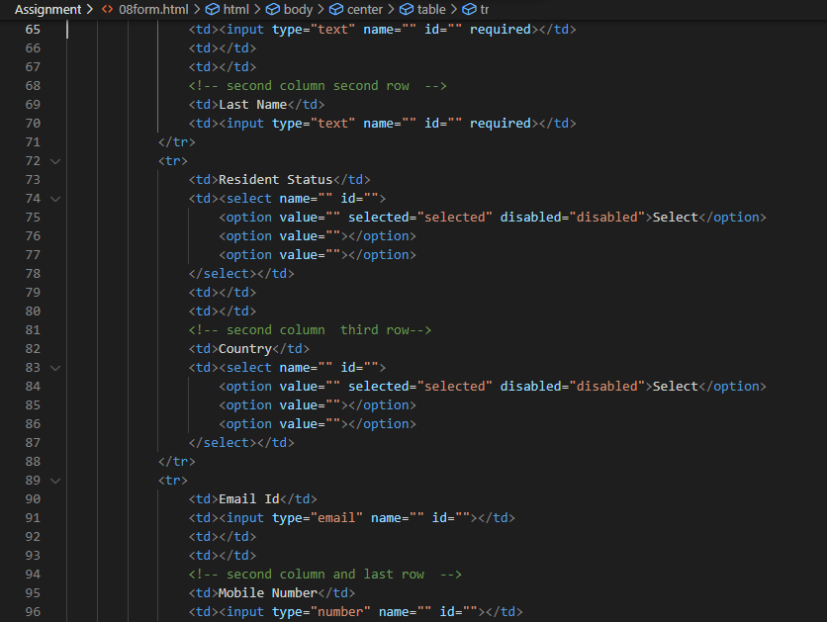

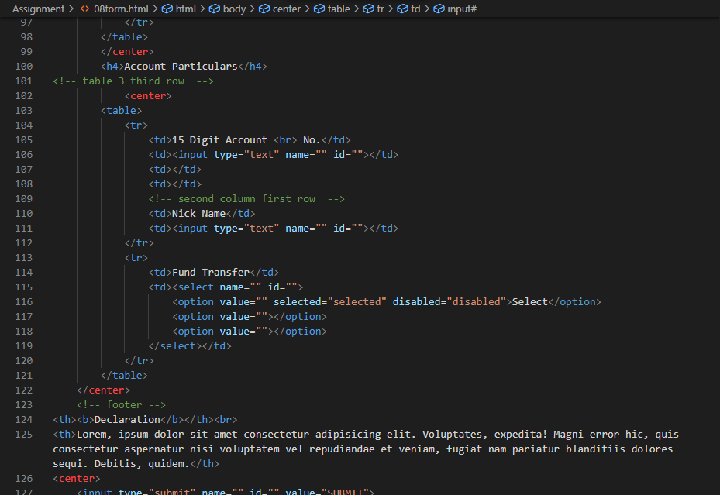

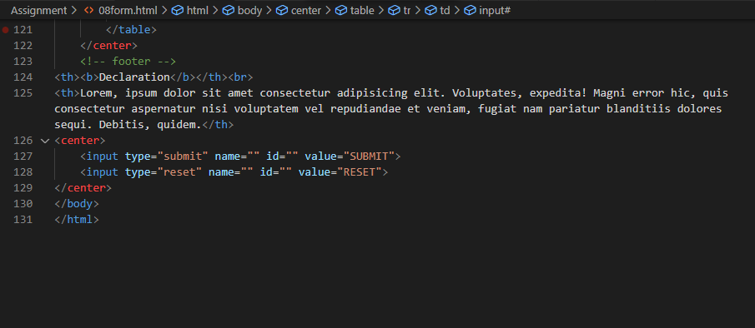

**OUTPUT:**

